VELAMMAL BODHI CAMPUS
PART TEST-I
CLASS:X SCIENCE Date : 07.10.2023
Duration : 3Hrs. Marks : 80

SECTION –A( 3 1 = 3 )
Select and write one most appropriate option out of the four options given for each of the questions 1 – 20 (20X1=20M)
1.An object is placed at a distance of 40cm in front of a concave mirror of a focal length of 20 cm.The image produced is:
(a) virtual and inverted (b) real and erect
(c) real, inverted and of the opposite size as that of the object
(d) real, inverted and of the same size as that of the object
2. Which of the following can make a parallel beam of light when light from a point source is incident on it?
(a) Concave mirror as well as convex lens (b) Convex mirror as well as concave lens
(c) Two plane mirrors placed at 90° to each other
(d) Concave mirror as well as concave lens
3.Assertion(A) : White light is dispersed into its seven-colour components by a prism.
Reason (R): Different colours of light bend through different angles with respect to the incident ray as they pass through a prism.
(a) Both assertion and reason are true and Reason is the correct explanation of Assertion
(b)Both assertion and reason are trueand Reason is not the correct explanation of Assertion
(c) If Assertion is true , but Reason is false
(d)If Assertion is false , but Reason is true
4.The change in colour of the moist litmus paper in the given set up is due to
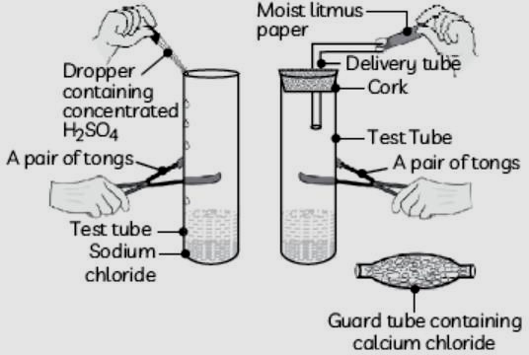
(I) presence of acid (II) presence of base
(III) presence of H⁺ (aq) in the solution (IV) presence of Litmus which acts as an indicator
(a) (I) and (II) (b) Only (II) (c) Only (III) (d) Only (IV)
5 .With the reference to four gases CO₂, CO, Cl₂ and O₂, which one of the options in the table is correct?
Option | Acidic oxide | Used in  treatment of water | Product of respiration | Product of incomplete combustion
(a) | CO | Cl₂ | O₂ | CO
(b) | CO₂ | Cl₂ | CO₂ | CO
(C) | CO₂ | O₂ | O₂ | CO₂
(d) | CO | O₂ | CO₂ | CO₂
6.
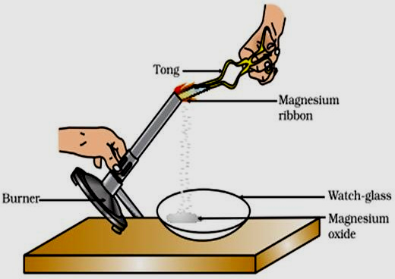
Which of the following is the correct observation of the reaction shown in the above setup?
(A)Brown powder of Magnesium oxide is formed.
(B) Colourless gas which turn slime water milky is evolved.
(C)Magnesium ribbon burn swith brilliant white light.
(D)Reddish brown gas with as mell of burning Sulphur hase volved
7) 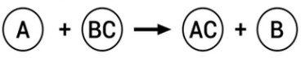 Identify the types of reaction mentioned above _________
a)combination b)decomposition c)displacement d)double displacement
8)The chemical formula of caustic potash is
(a) NaOH (b) Ca(OH)₂ (c) NH₄OH (D) KOH
9)The nature of calcium phosphate is present in tooth enamel is
(a) Basic (b) Amphoteric (c) Acidic (d) Neutral
10)Which of the following is a balanced chemical equation for the reaction between zinc and sulphuric acid?
a)Zn+H2SO₄→ZnSO₄+H₂O b) Zn+H₂SO₄→ZnSO₄+H₂
c) ZnSO₄+H₂O→Zn+ H₂SO₄ d) ZnSO₄+H₂→Zn+H₂SO₄
11) Assertion (A) : Decomposition of vegetable matter into compost is an example of exothermic reactions.
Reason (R) : Exothermic reaction are those reactions in which heat is evolved.
(a) Both A and R are true and R is the correct explanation of A.
(b) Both A and R are true but R is not the correct explanation of A.
(c) A is true but R is false. (d) A is false but R is true.
12. During photosynthesis Oxygen is liberated from
a) Chlorophyll b) CO2 c) H2O d) Atmosphere
13. Which element is required for the formation of chlorophyll molecule
a) Calcium b) Magnesium c) Iron d) Sodium
14.Which of the following constitute food chain
a) Grass, wheat and mango b) Grass, goat and human
c) Goat, cow and elephant d) Grass, fish and goat
15.Ozone forms by the combination of free oxygen atoms and oxygen molecules. How do free oxygen atoms form at higher levels of the atmosphere?
a) By splitting molecular oxygen into free oxygen atoms in the presence of low-energy UV radiations
b) By splitting molecular oxygen into free oxygen atoms in the presence of high-energy UV radiations
c) By the combination of two molecular oxygen in the presence of high energy UV radiations
d) By the combination of two free oxygen atoms in the presence of lower energy UV radiations
16.Which of the following is the correct equation for aerobic respiration?
a) Glucose + Oxygen → Carbon dioxide + Water + Energy
b) Carbon dioxide + Water + Energy → Glucose + Oxygen
c) Glucose + Carbon dioxide →Water + Oxygen + Energy
d) Oxygen + Water → Glucose + Carbon dioxide + Energy
17.Which of the following isthe correct pathway of urine in the excretory system?
a) Kidney → ureter → bladder→ urethra → outside the body
b) Bladder → urethra → kidney → ureter → outside the body
c) Kidney →bladder → urethra → ureter → outside the body
d) Urethra → bladder → kidney → ureter → outside the body
18.Chemicals present in tobacco smoke lead to the breakdown of the elastic tissue in the alveoli. Name this specific condition.
(a) Heart disease (b) Emphysema (c) Bronchitis (d) Lung cancer
19. What is the percentage of oxygen in the expired air when a person is resting?
(a) 12% (b) 16% (c) 20% (d) 24%
20. Assertion: Biodegradable substances result in the formation of compost and natural replenishment.
Reason: It is due to breakdown of complex inorganic substances into simple organic substances
a) Both the Assertion and the Reason are correct and the Reason is the correct explanation of the Assertion.
(b) The Assertion and the Reason are correct but the Reason is not the correct explanation of the Assertion.
(c) Assertion is true but the Reason is false.
(d) The statement of the Assertion is false but the Reason is true.
SECTION – B
Q. No. 21 to 26 are very short answer questions. (6 2 = 12)
21. What is meant by power of a lens? Write its SI unit. A student uses a lens of focal length 40 cm and another of -20 cm. Write the nature and power of each lens.
22.Explain why the planets do not twinkle?
Or
What is ‘dispersion of white light’? State its cause
23) a)Why do acids not show acidic behaviour in the absence of water?
Or
b) what does one mean by exothermic and endothermic reactions ?Give examples.
24. Why are you advised not to talk while you eat food ?
25.Differentiate between photosynthesis and respiration.?
26. Define the following terms:
a) Bio-accumilation b) Bio-magnification
SECTION – C
Q.no. 27 to 33 are short answer questions (7 3 = 21)
27. A real image ^{th} of the size of an object is formed by a convex lens when the object is at a distance of 12 cm from it. Find the focal length of the lens.
Or
An object is placed at a distance of 60 cm from a concave lens of focal length 30 cm.
(i) Use lens formula to find the distance of the image from the lens
(ii) List four characteristics of the image (nature, position, size, erect/inverted) formed by the lens in this case
(iii) Draw ray diagram to justify your answer of pair
28.A concave mirror has a focal length of 20 cm. At what distance from the mirror should a 4 cm tall object be placed so that it forms an image at a distance of 30 cm from the mirror? Also calculate the size of the image formed.
29.Make a diagram to show how hypermetropia is corrected. The near point of a hypermetropic eye is 1 m. What is the power of the lens required to correct the defect ? Assume that the near point of the normal eye is 25 cm.
30) What do you mean by a precipitation reaction? Explain by giving example.
31) Explain the differences between the acids and bases?
32). What do you mean by double circulation of blood? why is double circulation needed in mammals and aves?
33). Explain the functioning of haemodialysis?
(Or)
How is formed food web and represent the flow chart of food web?
SECTION - D
Q.no. 34 to 36 are long answer questions (3 5 = 15m)
34. (a) Define focal length of a spherical lens.
(b) A divergent lens has a focal length of 30 cm. At what distance should an object of height 5 cm from the optical centre of the lens be placed so that its image is formed 15 cm away from the lens? Find the size of the image also.
(c) Draw a ray diagram to show the formation of image in the above situation.
Or
A spherical mirror produces an image of magnification -1.0 on a screen placed at a distance of 30 cm from the pole of the mirror.
(i) Write the type of mirror in this case.
(ii) What is the focal length of the mirror?
(iii) What is the nature of the images formed?
(iv) Draw the ray diagram to show the image formation in this case.
35.a) Draw a neat labelled diagram of Nephron?
b) Explain formation of urine in human being?
(Or)
b) Expand UNICEF and what are the main objectives of the Montreal Protocol?
36. a) Explain the following terms oxidation , reduction
b) Explain the following terms decomposition reaction , displacement reaction
SECTION - E
Q.no. 37 to 39 are case - based/data -based questions with 2 to 3 short sub - parts. Internal choice is provided in one of these sub-parts
37 Read the following and answer any four questions from (i) to (iv). 4X1=4M
Atmospheric refraction is the phenomenon of bending of light on passing through earth’s atmosphere. As we move above the surface of earth, density of air goes on decreasing. Local conditions like temperature etc. also affect the optical density of earth’s atmosphere. On account of atmospheric refraction, stars seen appear higher than they actual are; advanced sunrise; delayed sunset, oval appearance of the sun at sunrise and sunset; stars twinkle, planets do not.
(i) Due to atmospheric refraction, apparent length of the day
(a) increases (b) decreases (c) remains the same (d) all of these
(ii) Apparent position of the star appears raised due to
(a) atmospheric refraction (b) scattering of light (c) both (a) and (b) (d) none of these
(iii) Twinkling of stars and non-twinkling of planets is accounted for by
(a) scattering of light (b) dispersion of light (c) atmospheric refraction (d) none of these
iv)In absence of atmosphere, the colour of sky appears
(a) blue (b) black (c) red (d) yellow
38.Read the following and answer any four questions from (i) to (iv). 4X1=4M
The reaction between carbon dioxide and calcium hydroxide (lime water), Calcium hydroxide, which is a base, reacts with carbon dioxide to produce a salt and water. Since this is similar to the reaction between a base and an acid, we can conclude that nonmetallic oxides are acidic in nature.
Based on the above paragraph answer the following questions:
i) What is the nature of Carbon dioxide?
ii) Give another reaction of non- metallic oxide and a base?
iii) Arrange the following bases in increasing order: NaOH, Ca(OH)₂& Mg(OH)₂ .
iv) Write the complete reaction between calcium hydroxide and carbon dioxide with physical states?
39. Read the following passage and answer the questions: 4X1=4M
Plant transport systems will move energy stores from leaves and raw materials from roots. These two pathways are constructed as independently organised conducting tubes. One, the xylem moves water and minerals obtained from the soil. The other, phloem transports products of photosynthesis from the leaves where they are synthesised to other parts of the plant
i) What are the different parts of xylem?
ii) What are the advantages of transpiration?
iii) What is translocation?
v) How does plant remove their waste product?

